Figure A: Heatmap of cytokine expression profiles in ACS patients with and without cardiogenic shock
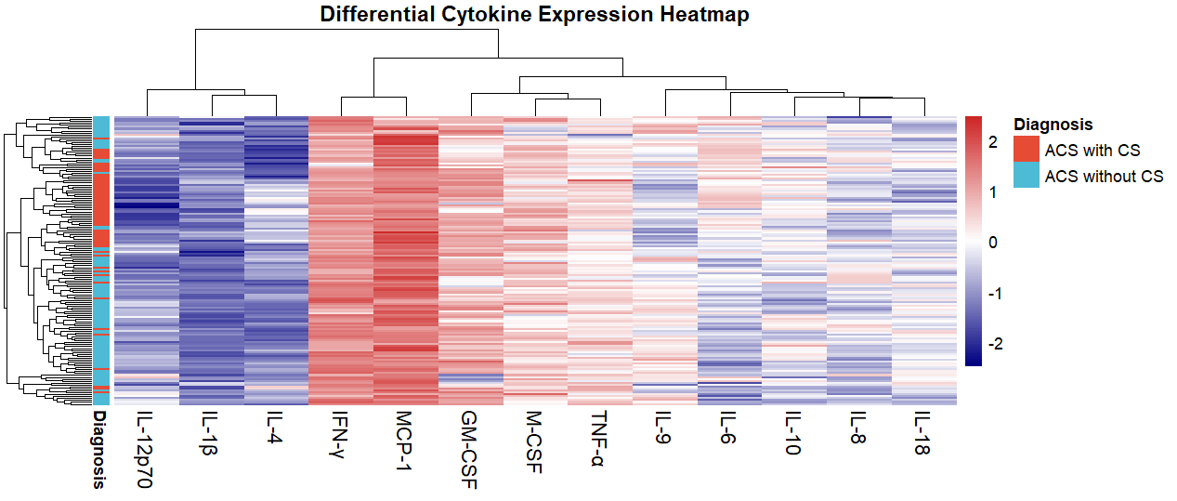
Supervised heatmap displaying log₂-transformed serum cytokine expression for all 13 analytes across individual ACS-CS (n = 60) and ACS-noCS (n = 90) patients. Rows represent cytokines; columns represent individual patients. Colour intensity corresponds to relative cytokine expression level (colour scale: blue = lower expression; red = higher expression). Hierarchical clustering was performed using Ward's linkage method. ACS-CS patients exhibit a distinct and coherent cluster of broadly elevated cytokine expression compared to ACS-noCS patients, indicating a coordinated, broad-spectrum systemic inflammatory response in cardiogenic shock rather than isolated upregulation of individual mediators. Cluster boundaries between the two groups are visually apparent, supporting the concept of an immunologically distinct phenotype in ACS-CS. ACS = acute coronary syndrome; CS = cardiogenic shock; IL = interleukin; TNF-α = tumour necrosis factor-alpha; GM-CSF = granulocyte-macrophage colony-stimulating factor; M-CSF = macrophage colony-stimulating factor; MCP-1 = monocyte chemoattractant protein-1; IFN-γ = interferon-gamma.
Figure B: Principal component analysis (PCA) of cytokine profiles demonstrating group separation in ACS patients with and without cardiogenic shock
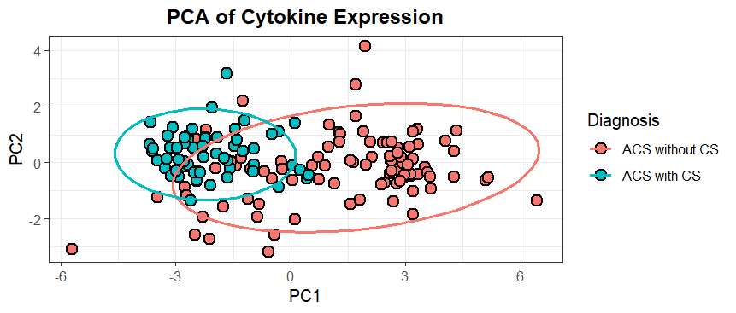
Scatter plot of principal component analysis (PCA) performed on log₂-transformed serum concentrations of all 13 cytokines. Each data point represents an individual patient; ACS-CS patients are represented by one colour/symbol and ACS-noCS patients by another. PC1 (x-axis) and PC2 (y-axis) represent the first and second principal components, respectively, capturing the maximum proportion of variance in the 13-cytokine dataset. A visible separation is observed between ACS-CS and ACS-noCS groups along PC1, indicating systematic differences in overall cytokine profiles between the two cohorts. Some overlap between groups is present, consistent with the biological heterogeneity of ACS and the multifactorial nature of cardiogenic shock. PCA = principal component analysis; ACS = acute coronary syndrome; CS = cardiogenic shock; PC1 = first principal component; PC2 = second principal component.
Figure C: Inter-cytokine correlation matrix in ACS patients with and without cardiogenic shock
Value
-1
Blue → negative correlation
Red → positive correlation
White → weak/no correlation
+1
0
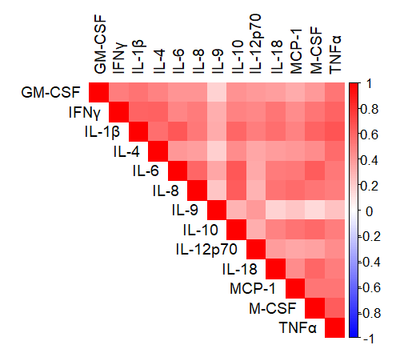
Heatmap of Pearson correlation coefficients among 13 serum cytokines across the study cohort (n = 150). Colour scale ranges from blue (r = −1) to red (r = +1) with white indicating minimal correlation. Strong positive correlations were observed between IL-6, TNF-α and IL-1β (r = 0.50 – 0.63) while GM-CSF showed moderate correlations with multiple cytokines (r = 0.33 – 0.53). IL-9 and IL-10 demonstrated weak correlations (r < 0.30) suggesting relative independence.

Figure D: STRING-based protein–protein interaction (PPI) network of the 13-cytokine panel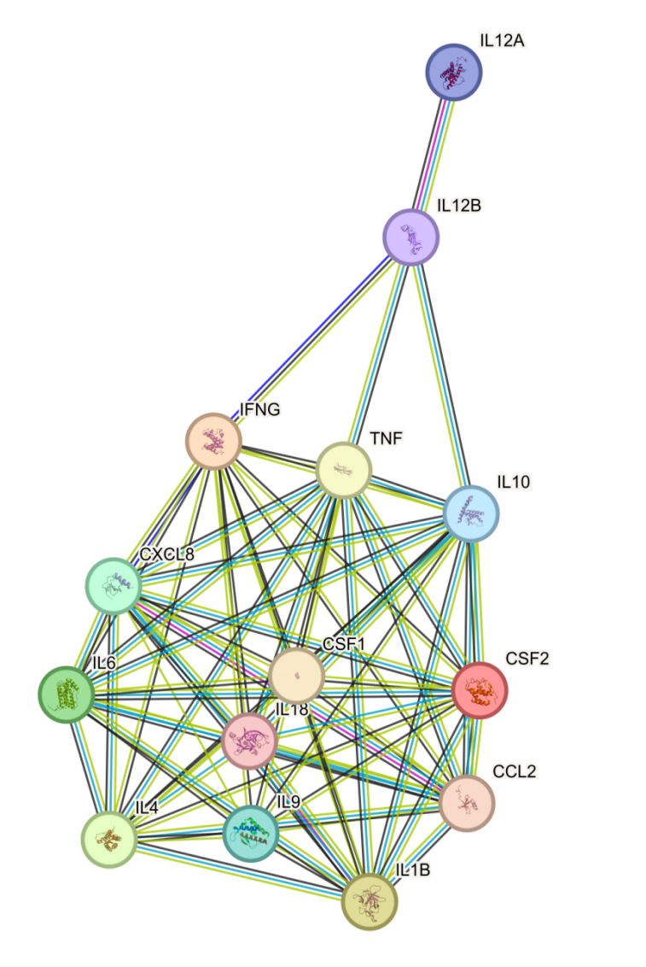
Protein-protein interaction network of the 13 serum cytokines constructed using STRING (v11.5; confidence ≥ 0.70). IL-12p70 is represented by its two subunits (IL12A and IL12B), giving 14 nodes. Coloured lines indicate the types of evidence supporting each interaction. The remaining 12 proteins were densely interconnected while IL12B was linked to IFN-γ, TNF-α, IL-10 and IL12A only to IL12B. PPI enrichment p < 1.0 × 10⁻¹⁶. KEGG analysis highlighted cytokine-receptor interaction, NF-κB signalling, interleukin signalling and TNF signalling pathways.
Figure E: Random forest multi-cytokine classification model for cardiogenic shock in ACS patients
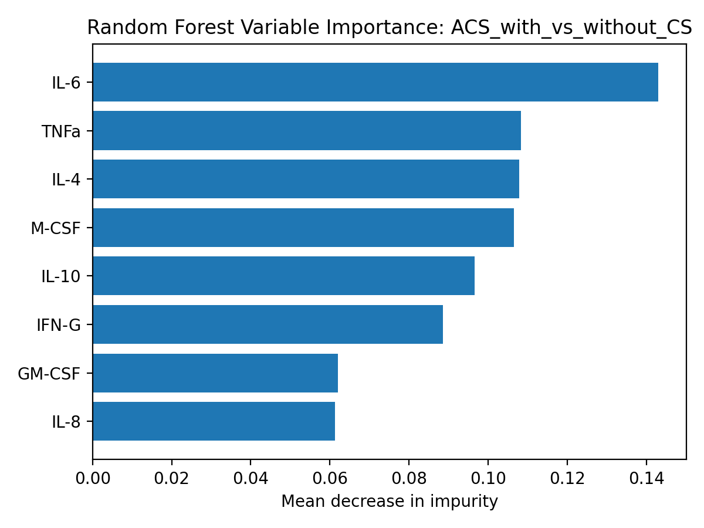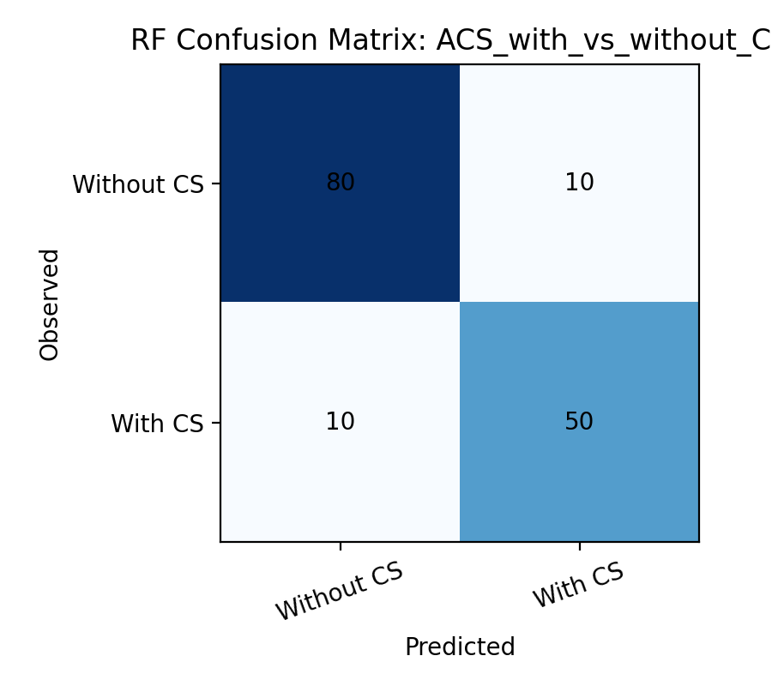

Random forest model using 13 cytokines to discriminate ACS-CS from ACS-noCS. (A) ROC curve of the cross-validated model (500 trees; 5-fold) showing AUC 0.958 and accuracy 86.7%, outperforming individual cytokines. Confusion matrix showed correct classification of 88.9% ACS-noCS (80/90) and 83.3% ACS-CS (50/60). (B) Variable importance plot identified IL-6 (0.143) as the top contributor followed by TNF-α (0.108), IL-4 (0.108), M-CSF (0.107) and IL-10 (0.097), supporting the added value of multi-cytokine profiling.

Table 1: ROC analysis: Individual performance of the five leading cytokines for CS identification
Cytokine | AUC | Optimal Cut-off | Sensitivity (%) | Specificity (%)
IL-6 | 0.870 | 68.22 pg/mL | 85.0 | 78.9
IL-10 | 0.847 | 60.63 pg/mL | 86.7 | 74.4
M-CSF | 0.847 | 169.91 pg/mL | 88.3 | 73.3
TNF-α | 0.841 | 116.78 pg/mL | 90.0 | 72.2
IL-1β | 0.822 | 8.45 pg/mL | 81.7 | 76.7

Table 2: GEO datasets used for cytokine panel selection
GEO accession | Assay / platform | Sample type | Country | Groups (n) | Comparison analyzed | Key cytokine-related DEGs identified | Panel analytes supported | Evidence tier
GSE202937 | Targeted NGS (miRNA/lncRNA); Ion Torrent Proton | Whole blood | Egypt | ACS 11; healthy control 1 | ACS vs control | CXCL10, TNFSF10, IFI44, CSF1R, IL15, IL4I1, IL31RA, IL18BP | M-CSF (via CSF1R) and IL-18 (via IL18BP); chemokine activation axis supporting MCP-1 inclusion | Primary (HC comparator)
GSE60993 | Expression microarray; Illumina HumanWG-6 v3.0 BeadChip | Serum | South Korea | Healthy control 7; STEMI 7; NSTEMI 10; UA 9 | STEMI vs control; STEMI vs UA | IL6, TNF, CXCL8, IL18R1, IL2RB, IRAK3, MMP9, LTB4R, IFRD1 | IL-6, TNF-α, IL-8 and IL-18 | Primary (HC comparator)
GSE179645 | Bulk RNA-seq; BGISEQ-500 | Whole blood | Egypt | ACS 3; PCI non-restenosis 3; PCI restenosis 3; healthy control 3 | ACS vs control; ACS vs PCI | ALOX15, SIGLEC8, IGLC6, PRSS33, BEGAIN | Th2 and eosinophil activation axis (ALOX15, SIGLEC8), supporting IL-4 and IL-9 inclusion | Primary (HC comparator)
GSE252710 | circRNA-seq; Illumina HiSeq 4000 | PBMC | China | Healthy control 3; UA 3; ACS 3 | ACS vs UA; control vs UA | C4BPA, CD177, HLA-DQA1, HLA-DQB1, TMEM176A, NECTIN2 | Innate and adaptive activation axis (CD177, HLA class II), supporting IFN-γ and IL-12p70 inclusion | Primary (HC comparator)
GSE236610 | Bulk RNA-seq (SMART-seq); Illumina NovaSeq 6000 | Coronary plaque | USA | ACS 14; stable CAD 13 | ACS vs stable CAD | FN1, TNIP1, IL7R, HLA-B, DOCK8, MAP1B | NF-κB and IL-6 signalling axis (TNIP1, HLA-B, IL7R), supporting IL-6 and TNF-α inclusion | Supportive (stable CAD comparator)
GSE184073 | Single-cell RNA-seq; Illumina NovaSeq 6000 | Coronary plaque | Japan | ACS 1; stable angina 1 | ACS vs SAP (cell-type composition) | IL1B, TNF, CXCL3, CSF1R, ITGAM, APOE, ABCA1 | IL-1β, TNF-α and M-CSF (via CSF1R); myeloid activation axis supporting GM-CSF inclusion | Supportive (n = 1 per group; exploratory)
Differential expression thresholds: |log₂FC| > 1, p < 0.05, FDR-adjusted p < 0.05; DESeq2 for RNA-seq and limma for microarray data. GSE184073 comprised one patient per group and was analyzed for cell-type composition rather than formal differential expression. Datasets with healthy-control comparators (GSE202937, GSE60993, GSE179645, GSE252710) were treated as primary evidence and those with stable CAD or stable angina comparators (GSE236610, GSE184073) as supportive.
As stated in Section 2.6, analytes were selected against four pre-specified criteria — differential expression, network centrality, literature validation in ACS and Luminex assay availability with candidates required to satisfy one or more. All thirteen analytes were members of the significantly enriched KEGG pathways identified across datasets (cytokine–cytokine receptor interaction, JAK-STAT signalling, IL-17 signalling, lipid and atherosclerosis) and of the STRING protein–protein interaction network (Supplementary Figure D). Transcript-level differential expression was not required for inclusion for three reasons: none of the available datasets included patients with cardiogenic shock, so contrasts were restricted to ACS versus control or stable disease and could not identify analytes that vary across the severity spectrum; two datasets (GSE202937, GSE252710) profiled non-coding RNA and therefore did not assay cytokine mRNA and blood or plaque transcript abundance does not reliably predict circulating cytokine protein concentration. The panel was accordingly constructed to provide balanced coverage of the pro-inflammatory, anti-inflammatory, Th1, Th2 and myeloid growth factor axes required to characterize the inflammatory response across the ACS spectrum.

Table 3: Per-analyte summary statistics for the 13 serum cytokines in ACS patients with and without cardiogenic shock
Cytokine | ACS-CS (n = 60) | ACS-noCS (n = 90) | log₂FC | FDR | AUC
IL-6 | 178.39 [106.60–305.35] | 29.05 [12.50–63.15] | 2.62 | 2.47 × 10⁻¹³ | 0.870
IL-10 | 123.38 [78.92–205.35] | 34.95 [15.81–59.92] | 1.82 | 3.03 × 10⁻¹² | 0.847
M-CSF | 298.55 [208.27–431.26] | 88.75 [55.09–192.31] | 1.75 | 3.03 × 10⁻¹² | 0.847
TNF-α | 212.23 [134.06–292.41] | 67.75 [43.35–127.04] | 1.65 | 5.61 × 10⁻¹² | 0.841
IL-1β | 21.93 [10.33–37.93] | 4.67 [3.04–8.04] | 2.23 | 6.81 × 10⁻¹¹ | 0.822
GM-CSF | 561.22 [329.08–687.22] | 132.44 [75.97–231.19] | 2.08 | 1.57 × 10⁻¹⁰ | 0.815
IL-8 | 78.47 [50.90–134.63] | 31.18 [15.51–48.82] | 1.33 | 3.38 × 10⁻¹⁰ | 0.808
IL-4 | 44.51 [12.12–94.08] | 6.83 [4.31–11.20] | 2.70 | 6.22 × 10⁻¹⁰ | 0.802
IFN-γ | 691.31 [554.79–802.79] | 303.30 [198.45–546.31] | 1.19 | 8.92 × 10⁻⁹ | 0.781
MCP-1 | 978.43 [777.95–1697.06] | 573.43 [286.34–912.39] | 0.77 | 2.27 × 10⁻⁸ | 0.772
IL-18 | 88.12 [45.45–104.21] | 35.75 [19.59–68.55] | 1.30 | 1.47 × 10⁻⁶ | 0.734
IL-12p70 | 15.78 [8.90–29.61] | 11.77 [5.84–23.11] | 0.42 | 0.047 | 0.597
IL-9 | 72.31 [55.55–89.45] | 59.77 [42.20–105.66] | 0.27 | 0.245 | 0.556
Values are median [interquartile range] in pg/mL, ordered by AUC. Fold-change was calculated as the difference in median log₂ concentration between groups. Groups were compared using the Mann–Whitney U test with Benjamini–Hochberg correction across all 13 analytes. AUC values are for discrimination of cardiogenic shock. Eleven analytes met both pre-specified criteria (FDR < 0.05 and log₂FC > 0.5); IL-12p70 reached borderline statistical significance without meeting the fold-change threshold, and IL-9 was non-significant. ACS: acute coronary syndrome; CS: cardiogenic shock; log₂FC: log₂ fold-change; FDR: false discovery rate; AUC: area under the receiver operating characteristic curve; IL: interleukin; GM-CSF: granulocyte-macrophage colony-stimulating factor; M-CSF: macrophage colony-stimulating factor; MCP-1: monocyte chemoattractant protein-1; TNF-α: tumour necrosis factor-alpha; IFN-γ: interferon-gamma.

